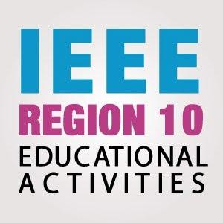

2022 IEEE R10 Educational Activities Call for workshops on TryEngineering & STEM
Before completing this proposal, please read all the Terms and References at https://ea.ieeer10.org/
Program Title
TISP / Try Engineering
IEEE Organizational Unit (branch code/Section name/ subsection )
Name of IEEE Organizational Unit Chair
IEEE Organizational Unit Counselor (for Student Branch only)
Project Leader / Educational Activity Chair of OU Details
Full Name
Email
Contact Number with country code
IEEE Membership Number
Program Team Members & Emails
Section Chair Name & Email
Executive Summary on proposal (maximum 300 words)
Introduction and Description of Program (including expenses)
Proposed budget:
No. | Items | Expense description | Proposed Budget ($USD)
1.
2.
3.
4.
 |  | TOTAL

Alignment with IEEE Goals and Effective Use of IEEE Resources
Measurement or Assessment of the Educational Outcomes
Impact of the program to the participants and community (outreach of program/ platform used/ joint event with other OU/ Target audience
Proposed platform and technology used
Planning for social media reach
Innovativeness aspect of the program
Prepared by Project Leader:  Name:  IEEE Membership No:  Signature (e-signature is allowed):  Date: |  | Endorsed by Council/Section/Subsection Chair with the commitment of providing the matching grant  Name:  IEEE Membership No:  Signature (e-signature is allowed):  Date
For more details and enquiries, please contact R10 Educational Activities Committee at: region10eab@gmail.com

